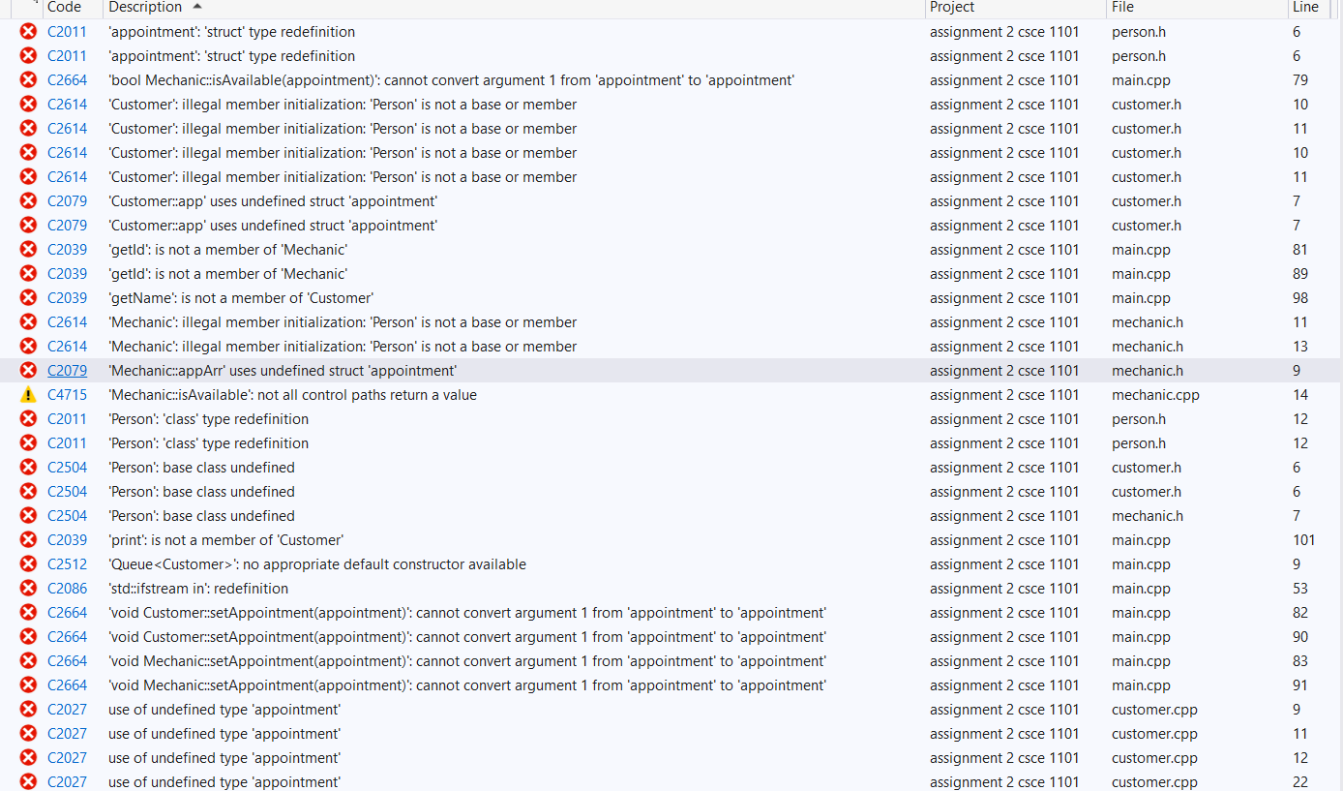

Errors in codes that I am unable to find a solution to. The code is correct but I am unsure why it is showing me so many errors. I even tried rewriting the code so that I can clear all the errors. This prevents the code from running

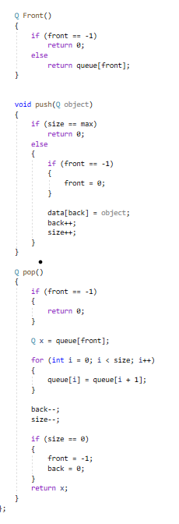I only made front,pop, and push functions since I did not find it necessary to use any other functions. The front function to be able to edit the variables if necessary.